* One shot learning: doesn’t need much labeled data or data in general. We need just one training example for each class.
* In traditional classification we need lots of data for each class
* How One shot learning works:

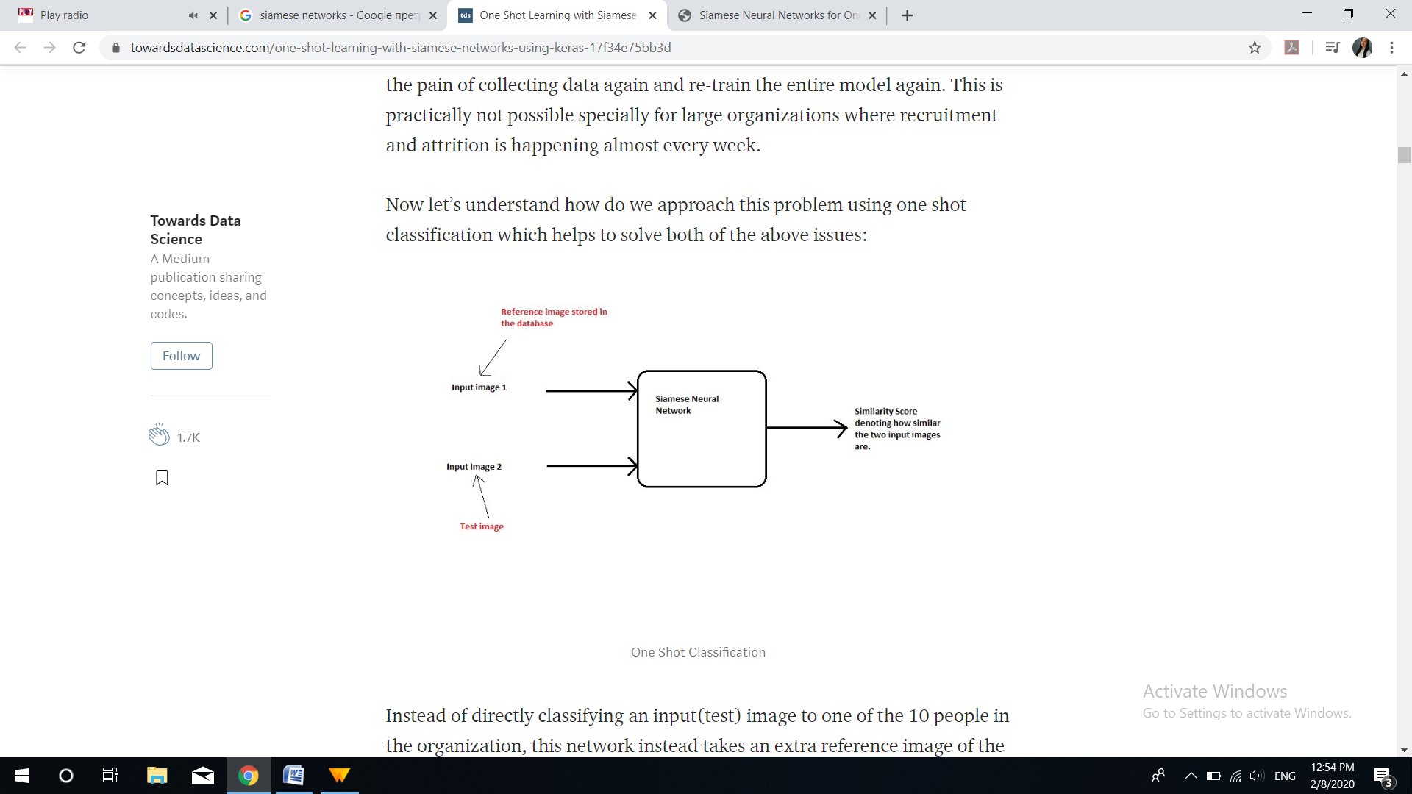

* Instead of directly classifying an input (test) image to one of the classes, this network instead takes an extra reference image of the person as input and will produce a similarity score denoting the chances that the two input images belong to the same person.
* Typically the similarity score is calculated using sigmoid function.
* This network doesn’t learn to classify image to output class, but it learns a similarity function.
* For training Siamese network, we take two RANDOM images from dataset

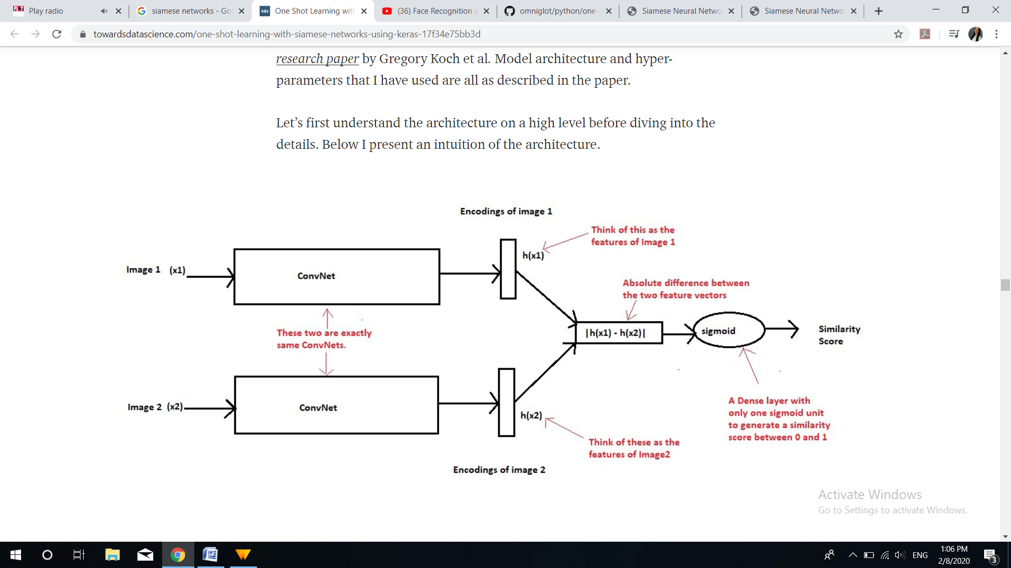

* Siamese Network: Two identical networks, with same parameters. Input image goes through network and its’ feature vector is calculated. The same happens for another image, which is passed to other “twin” network. So if the model is trained properly, if two images are similar, their feature vectors will be too
* N-way one shot learning: We compare input to N different images and decide which is the most similar to it. This is similar to KNN algorithm with K = 1.
* We compute Euclidean distance for similarity. We search for image with minimum distance.